Instructions for Lab 3

These instructions are copyrighted (all rights reserved). They are provided for non-profit educational use by the students currently enrolled in CSC 101 course at CSUDH and for the duration of this semester only. No other use or access is allowed without permission from the copyright holder or holders. See the class website http://csc.csudh.edu/suchenek/CSC101/ for more information.

Save the input file as List_of_students_out.txt in a new folder Lab3.

Open Microsoft Office Excel 2010.
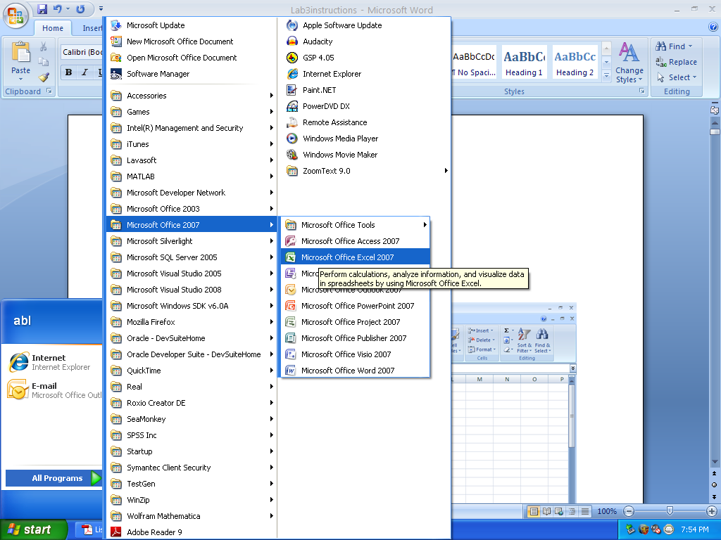

Open and import file List_of_students_out.txt.

After importing and adjusting column width, the spreadsheet should look like this:
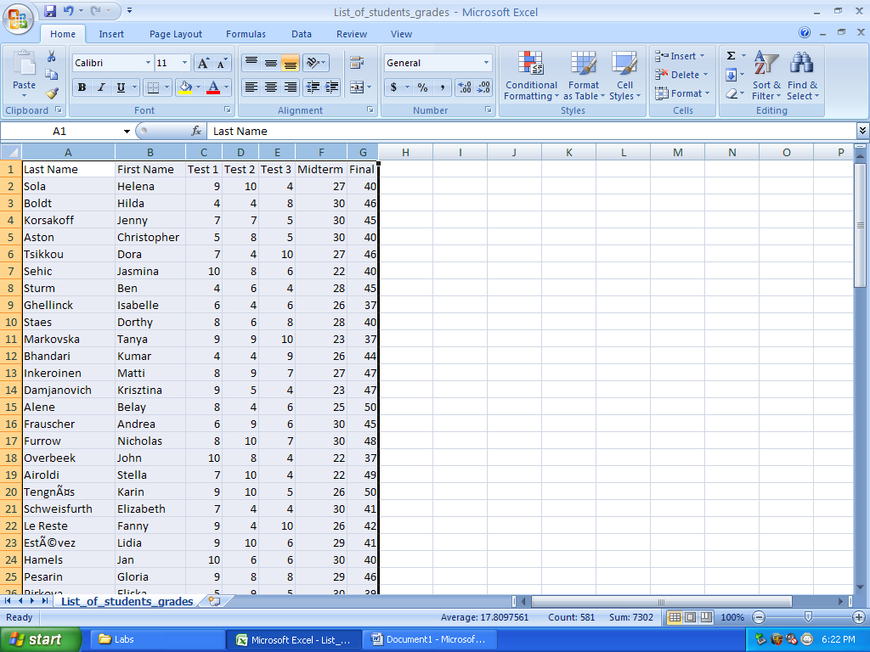

Save the spreadsheet you have just created as Gradebook.xls in the folder Lab3.

Insert new columns for Num, Grade, and Total Score. Fill column Num with consecutive numbers.
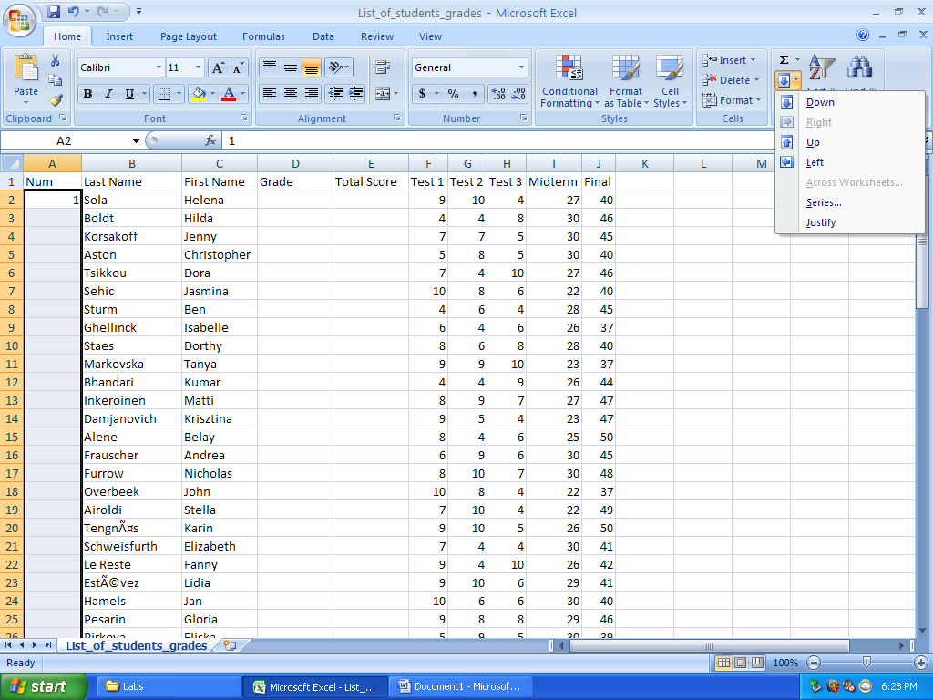

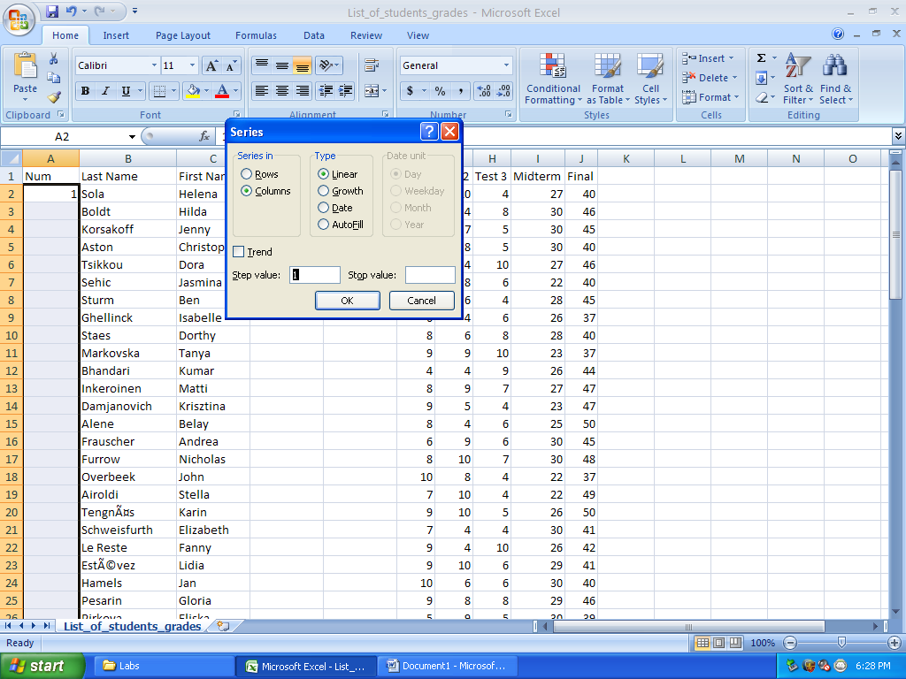
Enter =sum(F2:J2) into cell E2, with F2:J2 being fetched with mouse (point and drag).
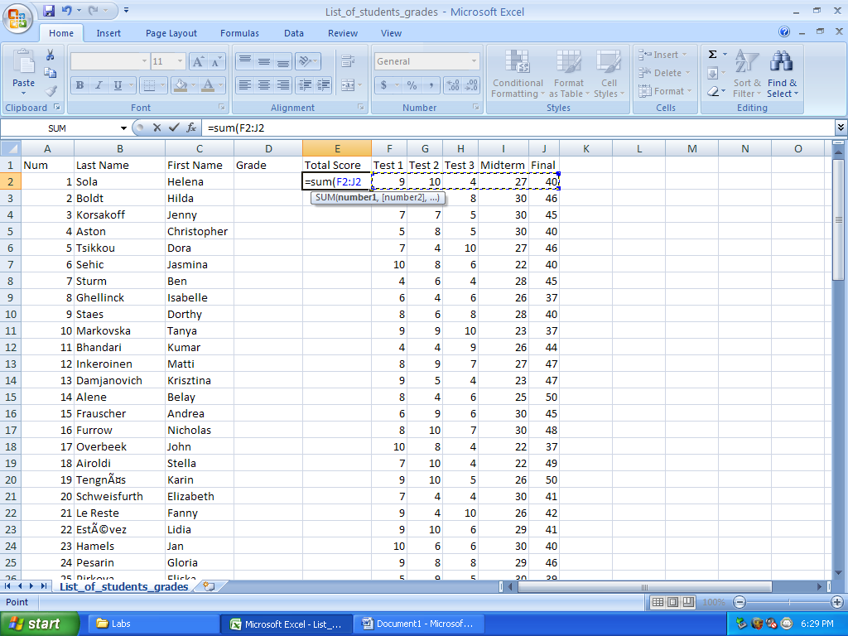

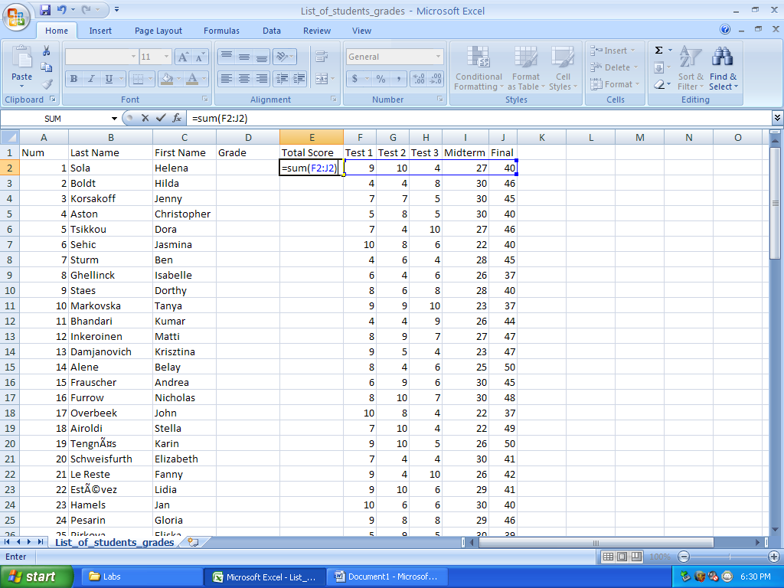

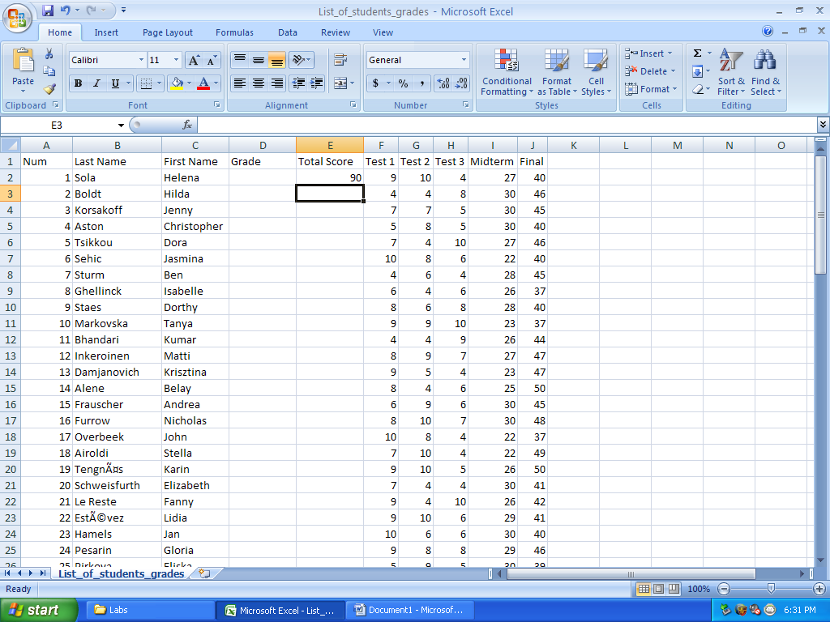
Enter
=IF(E2>89,"A",IF(E2>79,"B",IF(E2>69,"C",IF(E2>59,"D","F"))))
in cell D2.

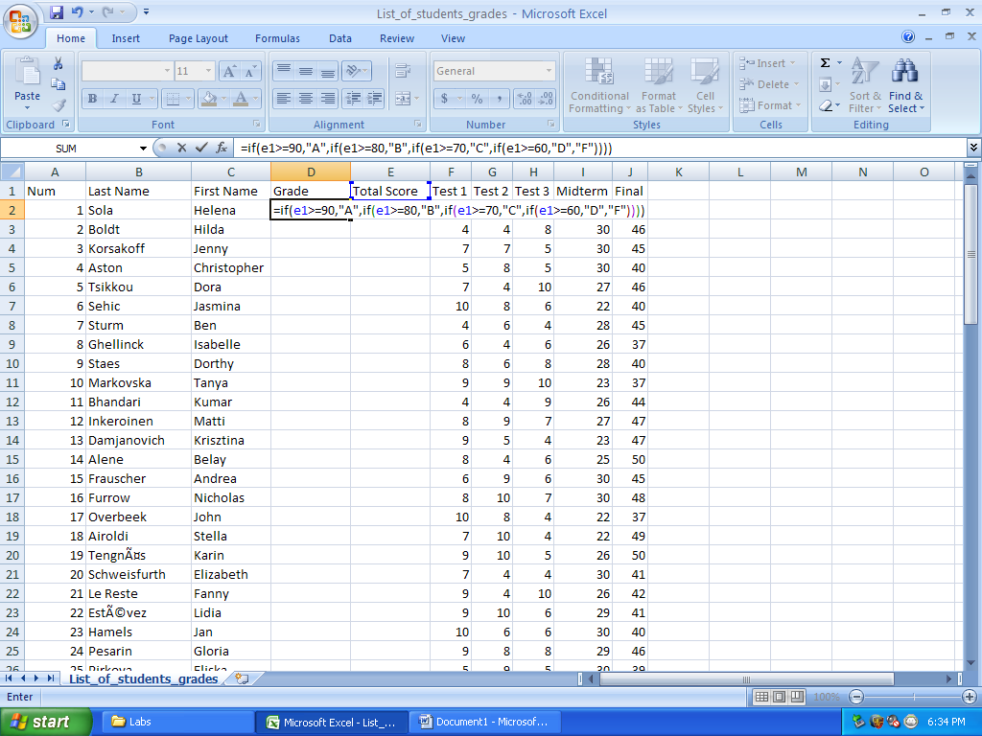

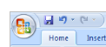
Save the spreadsheet by clicking on the “save” icon.

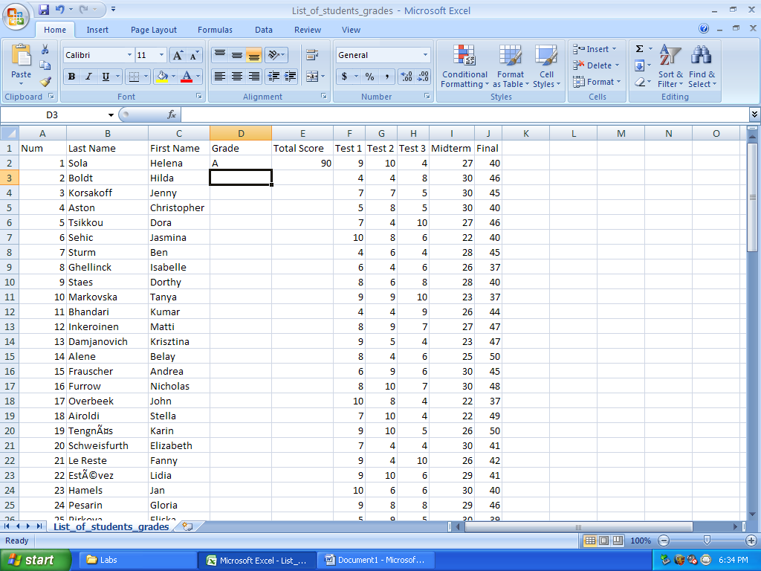
Copy and paste cells D2 and E2 to the entire columns D and E.
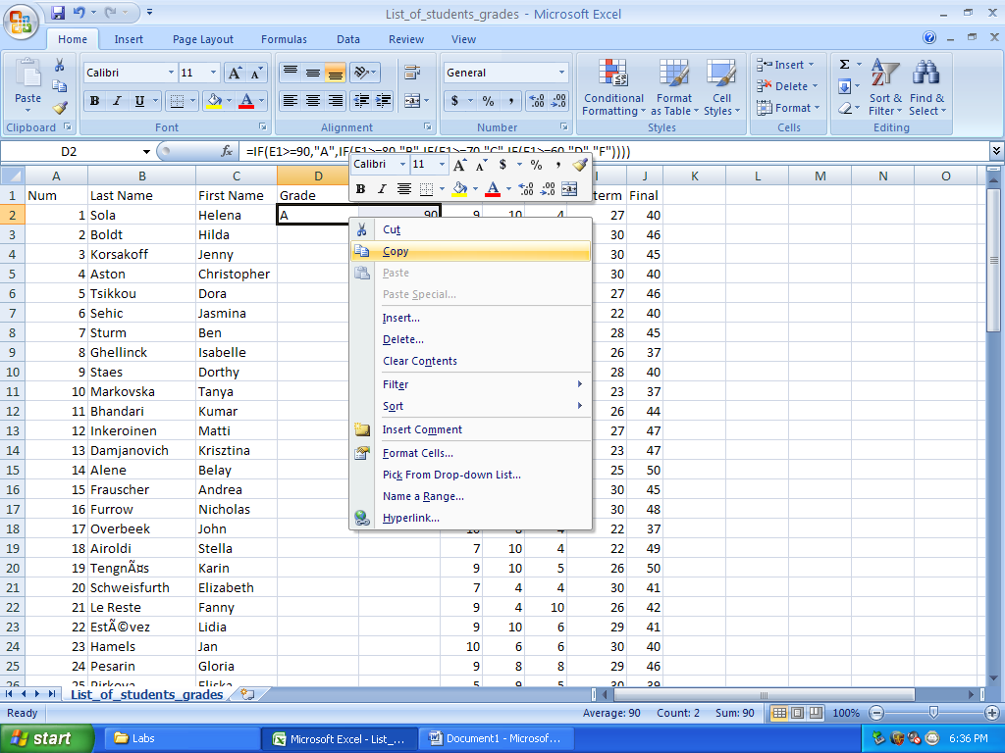

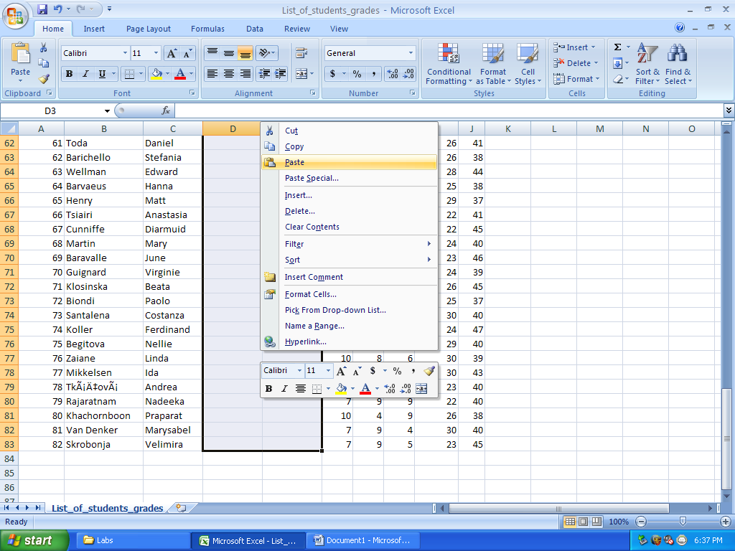

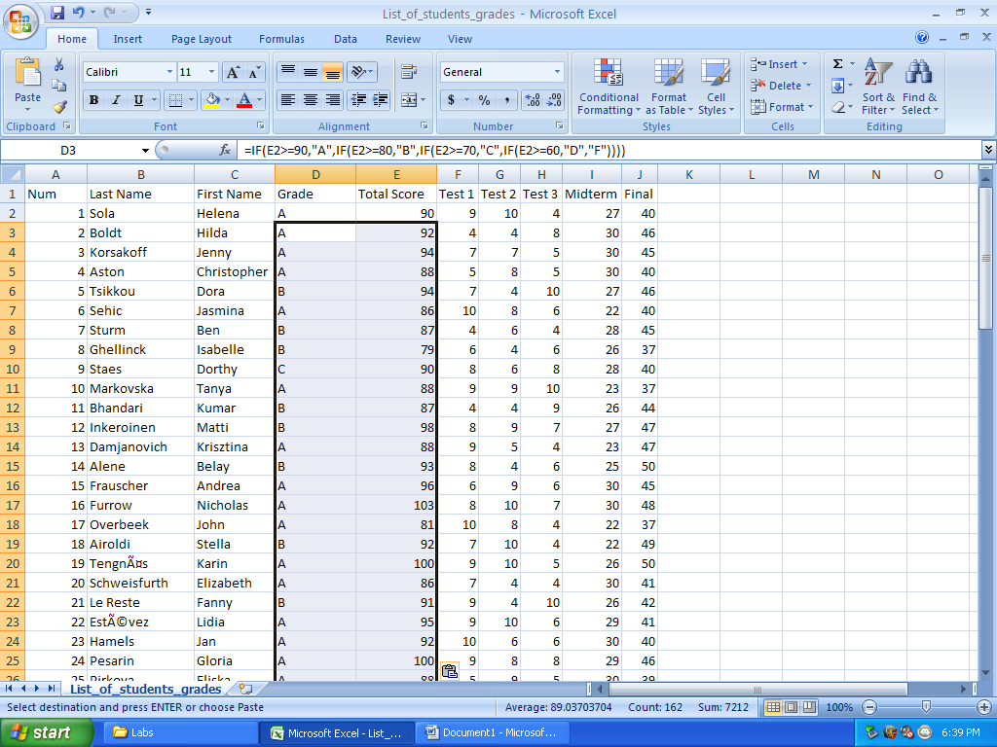

Reformat columns for nice alignment.
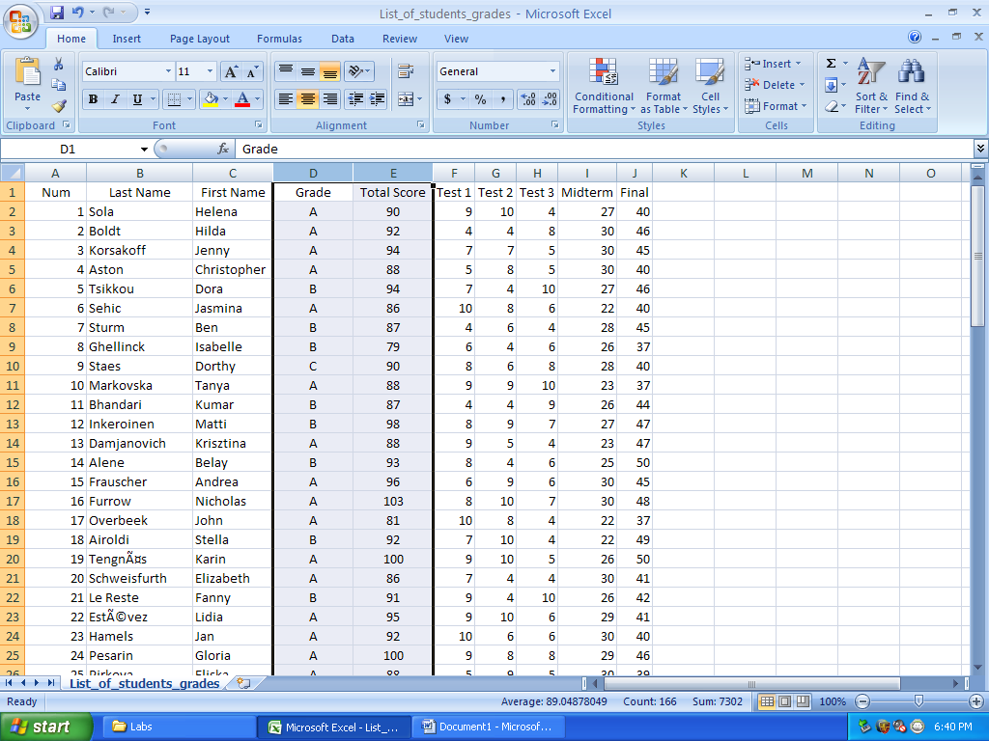

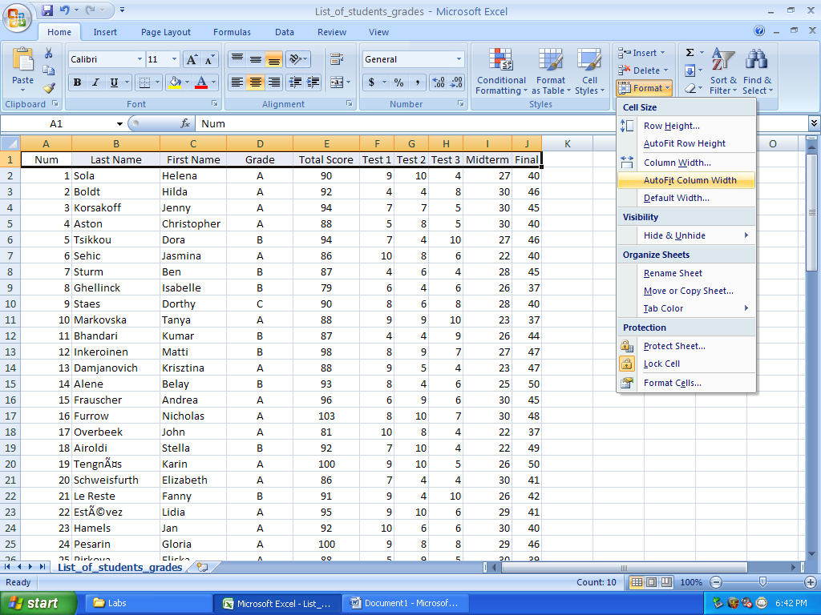

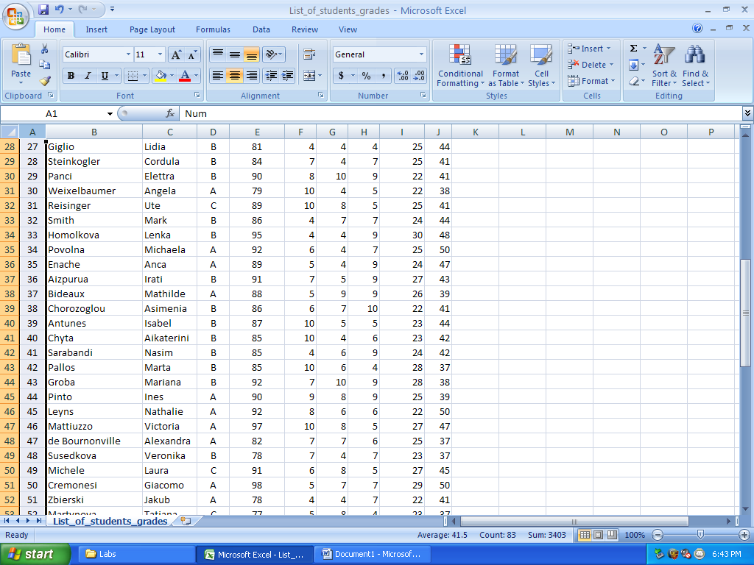

Save the spreadsheet by clicking on the “save” icon.

Sort the sheet by Last Name alphabetically. Re-fill column Num so that the numbers are consecutive.
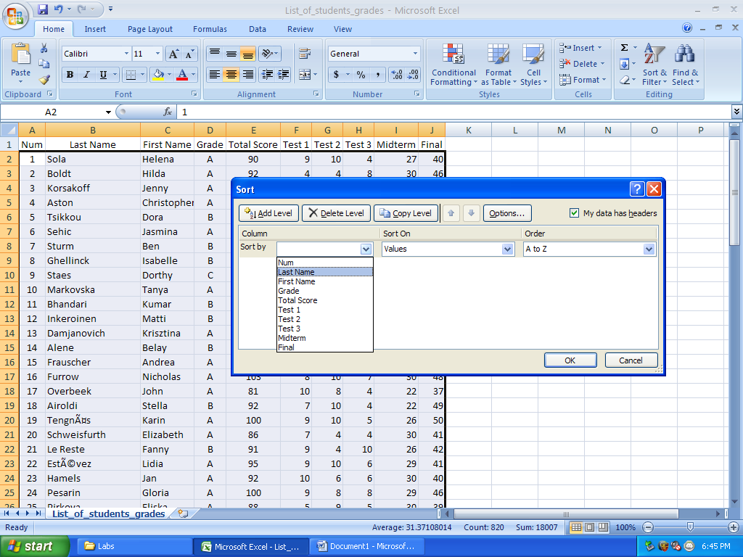

Insert new row in the place appropriate for your name.
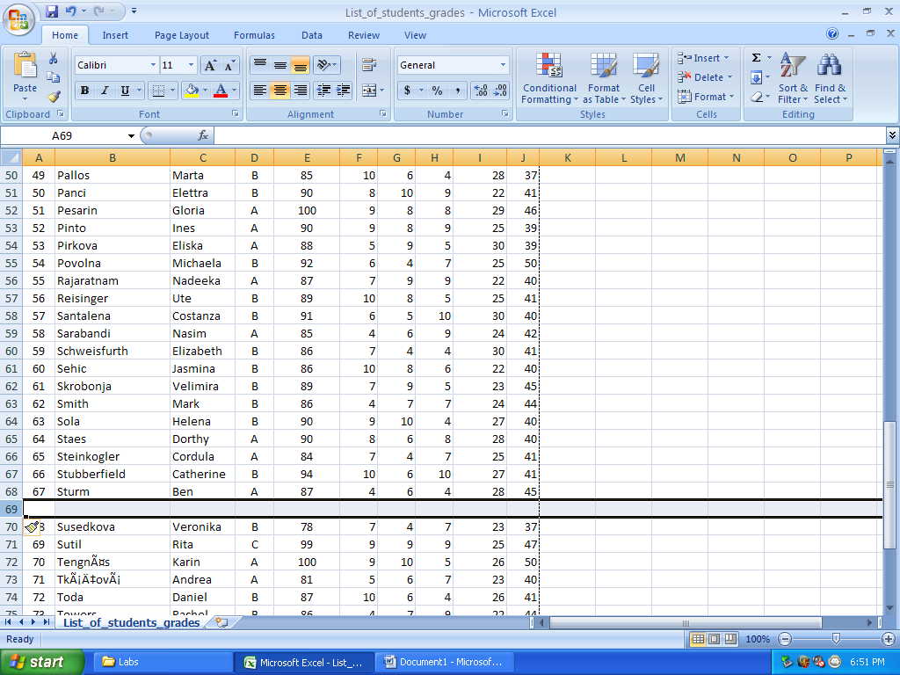
Type your first name, last name, scores for tests, midterm, and final.

Copy cells Dx and Ex (where x is the row above the row with your name), and paste them in right below.

Re-fill the Num column so that the numbers are consecutive.

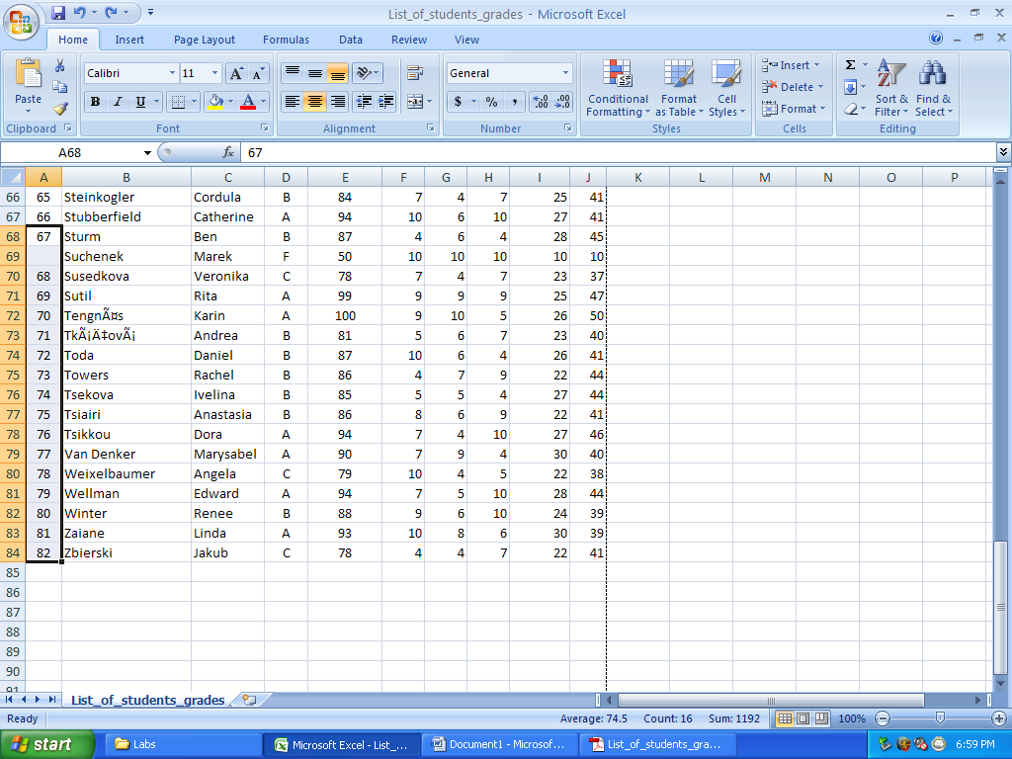

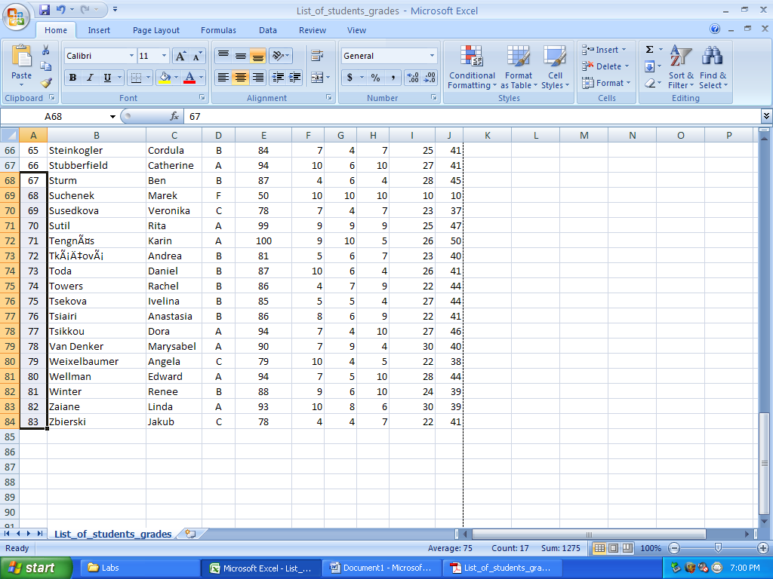

Save the spreadsheet by clicking on the “save” icon.

Output your sheet in PDF format as List_of_students_out.pdf.
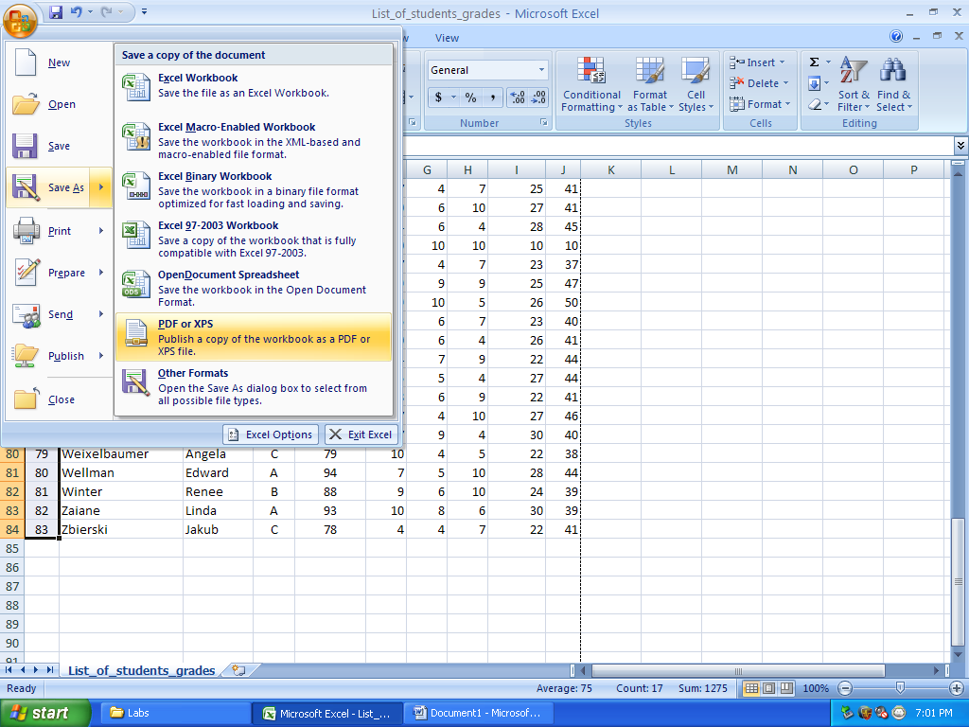

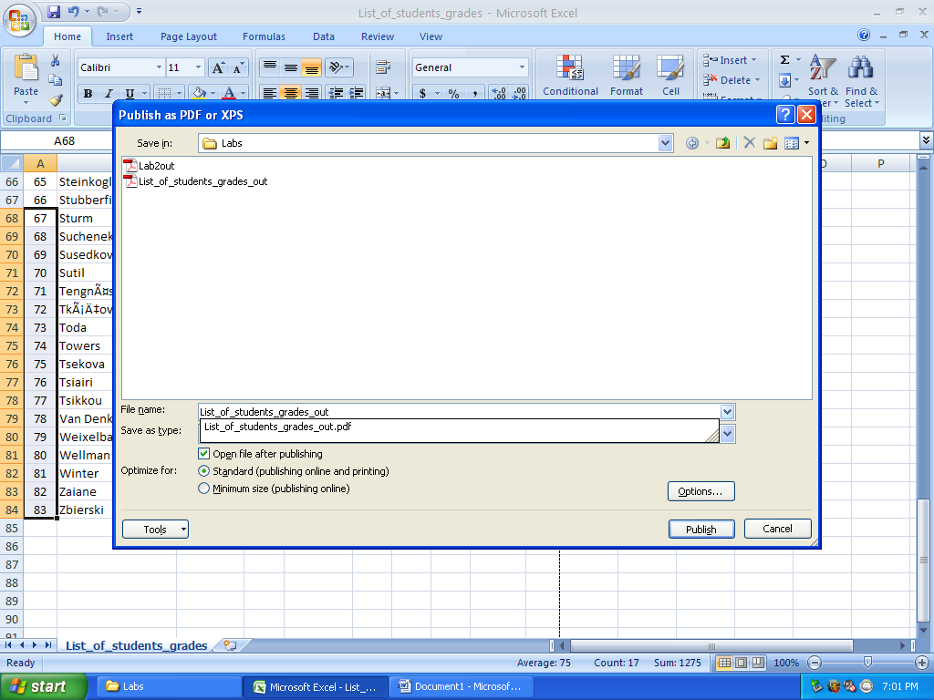

Now, sort the sheet by Total Score in decreasing order.
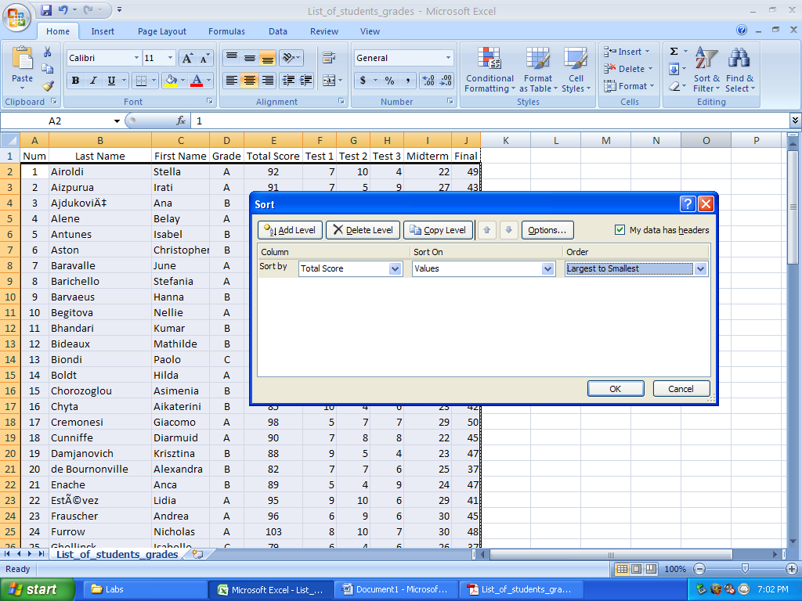
Copy columns A, B, C, D, E and paste them to a new sheet.
Adjust the width of all columns accordingly.
Make sure that after pasting, the new sheet is sorted by Total Score.
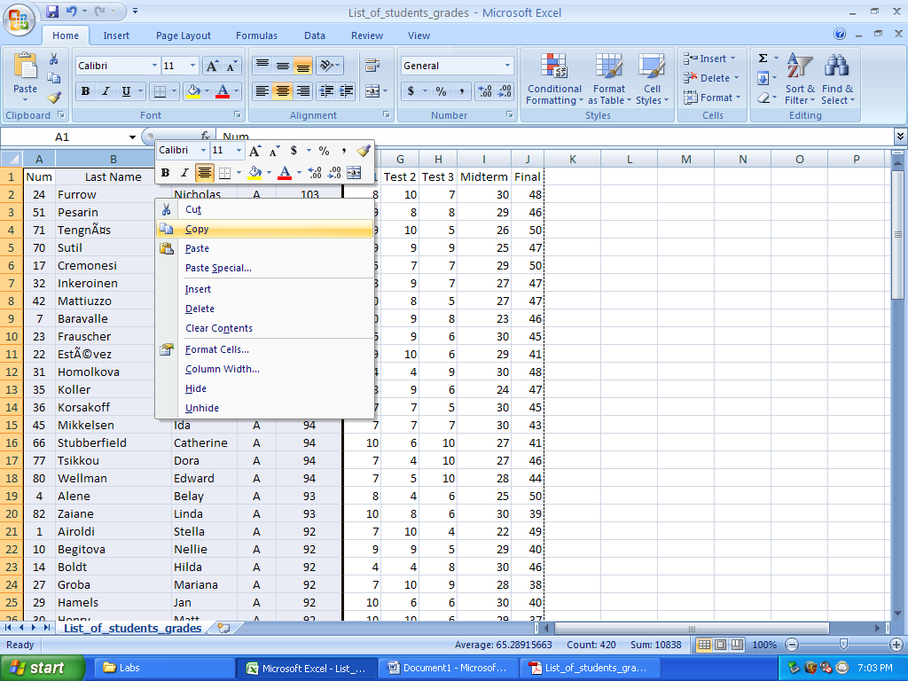

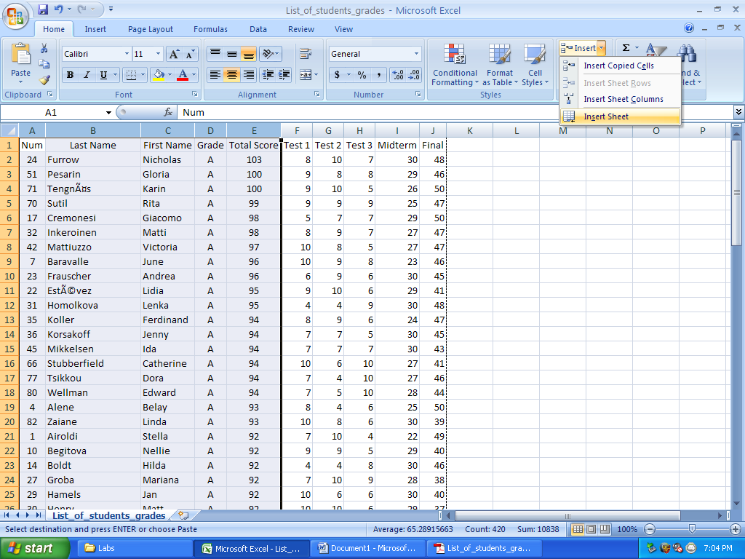

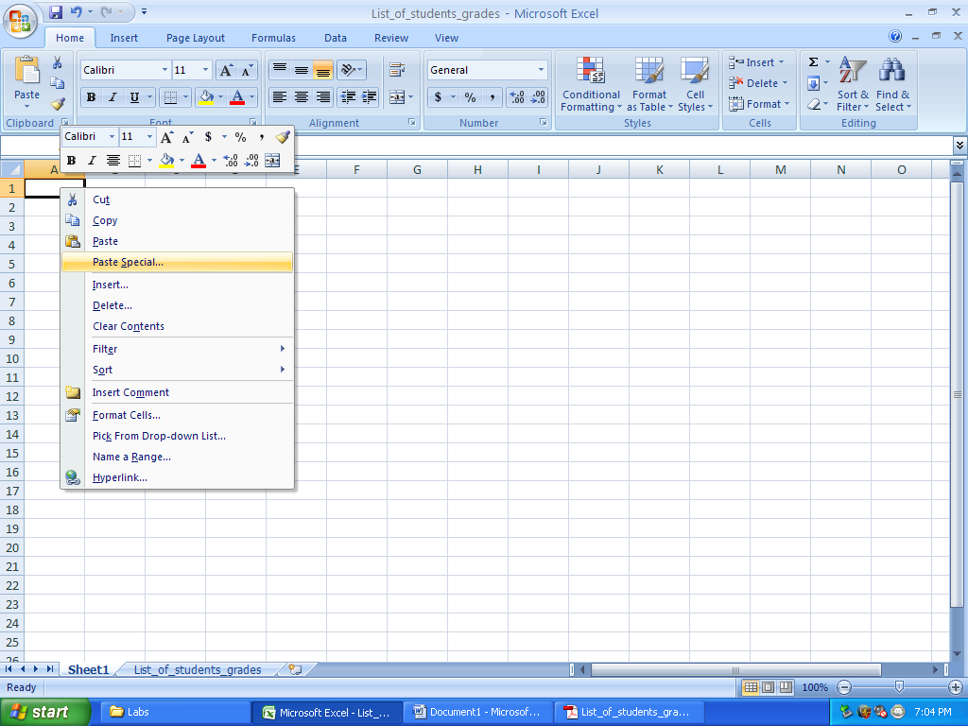

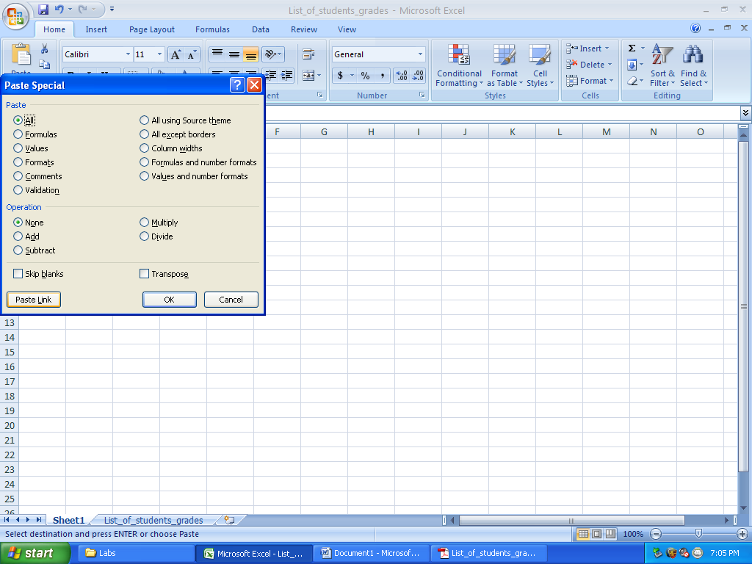

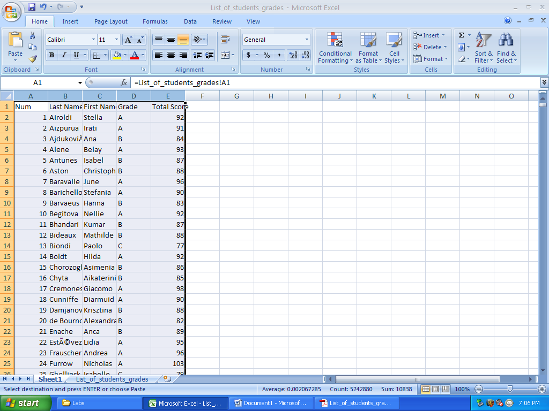

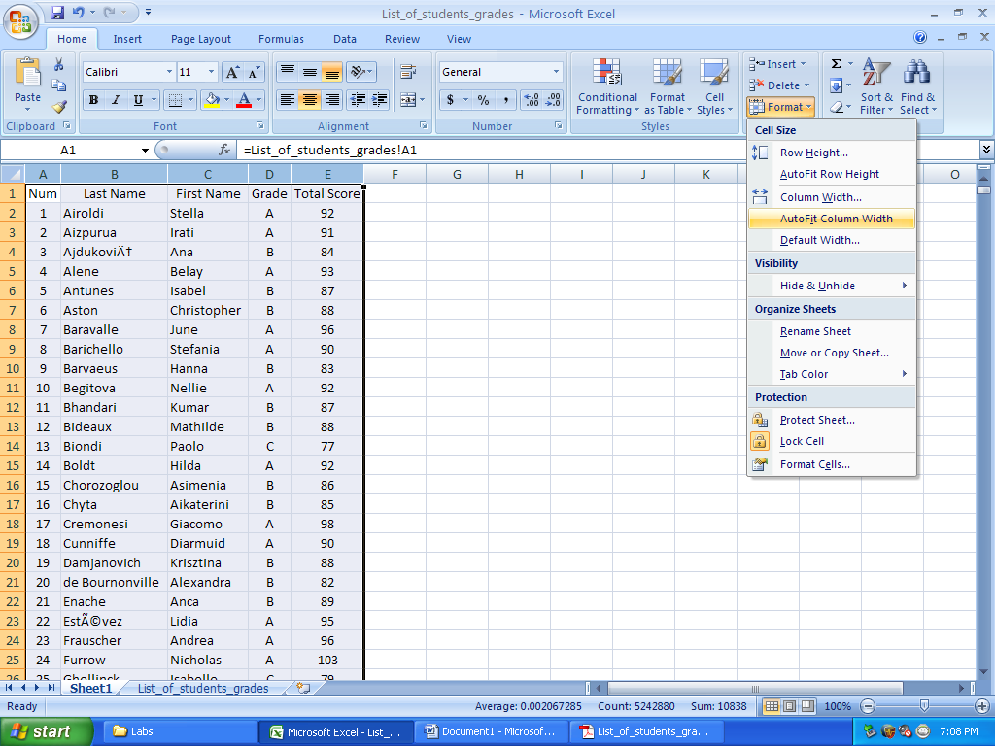
Rename the new sheet to Course_grades.

Save the spreadsheet by clicking on the “save” icon.

Save the new sheet in a PDF file List_of_students_out2.pdf
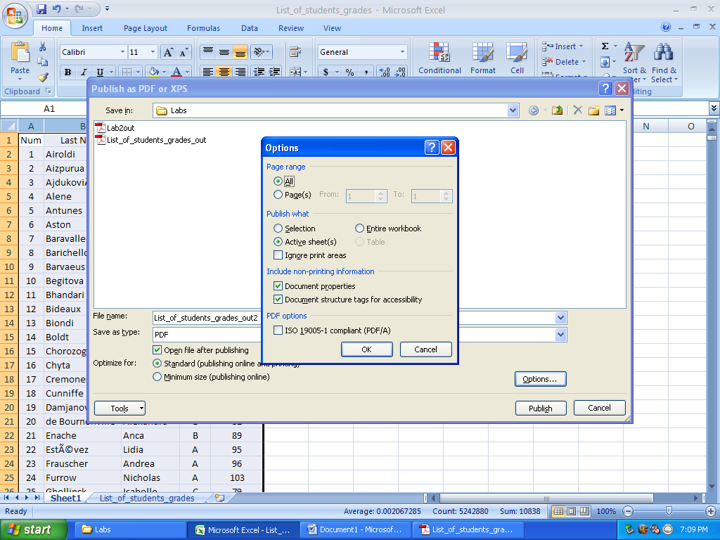

Print and submit both .pdf files for credit before you leave the classroom.

Have nice day!

